Music Genre Detection using Convolutional Neural Networks

Daksh Khandelwal
daksh.bs18bds013@spjain.org

Abstract – The purpose of this paper is to detect the genre of music on the basis of patterns. Every genre has different kinds of patterns, different frequencies. By analyzing these patterns and frequencies, we can predict the genre of the music. In this study, I have combined the use of Convolutional Neural Networks with traditional Deep learning activations like Softmax, ReLu, categorical-cross-entropy, and Optimizers such as Adam, RMSProp and SGD. I trained the CNN to remove patterns in the songs by creating a Mel-Spectrogram for every song.

I. INTRODUCTION:
Today, music is a very important and perhaps inseparable part of people's daily life. There are many genres of music and these genres are different from each other, resulting in people to have different preferences of music. As a result, it is an important and up-to-date issue to classify music and to recommend people new music in music listening applications and platforms. Classifying music by their genre is one of the most useful techniques used to solve this problem. Audio data has become an important feature of machine learning. We use audio to interact with voice assistants like Siri and Alexa. Audio will be important for self-driving cars so that they can not only see what is happening in their surroundings but also hear them. Apps like Spotify, Shazam and YouTube uses music and genre recognition to generate a playlist curated for every user. They use algorithms to keep suggesting a user with similar songs they might like. They predict such songs suggesting songs similar to the artist or genre of the music.
For humans to classify a genre, they can just listen to the song and classify the song as a particular genre. However, the contents of music are complex and music genres are not well defined, thus making it difficult for a machine to identify.
The goal of this paper is to run Deep Learning Models with various combinations and try to analyse which combination works best for predicting the genre by running with various optimizers. The methodology is as follows. I first try to create a MelSpectrogram for each song in our dataset. CNNs are used for image classification due to their high accuracy. I convert a song from being an audio data to an image. A MelSpectrogram is a visualized version of a song. After converting every song to an image, I split them in 80-10-10 format, with 80 percent training samples, 10 percent validation samples and 10 percent testing samples, with a shuffle.

II. RELATED WORKS
Music genre classification, as a branch of speech and audio, has been studied by many. The normal approach consists of feature extraction and classification.
To classify genre, characteristics like temporal features, transformations and filters are used. Majority of the genre classification studies focus on such characteristics. The author of the dataset also attempted to find the set of features that best represents a piece of music. Rhythm is defined as the placement of sounds in time. Rhythm analysis is the process to analyse such sounds to find patterns and correlations. There are a few studies that use such analysis to add new features to the classification problem. I think that such analysis reduces the accuracy of a model since such analysis is added at the expense of some important features that could be extracted by a neural network.
There are a few studies who have used traditional Machine learning models such as Logistic Regression and Hidden Markov Model, but they do not perform as well as deep learning frameworks such as Convolutional Neural Networks, which have a reputation to perform well and extract more features from images. In a study by T. LH. Li, A. B. Chan, and A. HW. Chun, they used MFCC audio representation and trained a music pattern extractor to classify music genre. MFCC is Mel Frequency Cepstral Coefficients. MFCC convert conventional frequencies to Mel Scale and are thus suitable for speech recognition tasks. Some studies have focused on a LSTM model, but they are mostly focused on lyrics generation.
III. DATASET AND REPRESENTATION
The dataset that I have used is taken from GTZAN. It consists of a total of one thousand songs, each song being 30-seconds long. The one thousand songs are equally divided into ten genres. Thus, each genre has a hundred songs in .wav format. The genres being blues, classical, country, disco, hip-hop, jazz, metal, pop, reggae and rock.
I use the Python library LibROSA to convert each audio to a Mel-Spectrogram. For the first song of every genre, I print out the song using the IPython.display library, the wave plot and its Mel-Spectrogram. I create Mel-Spectrograms for every song and run it through the Deep Learning Model.
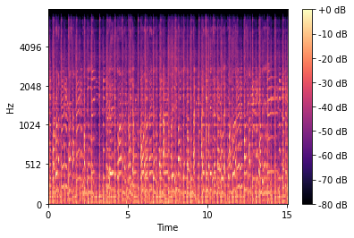
Figure: The above Figure represents the Mel-Spectrogram for a song from the genre category - blues.
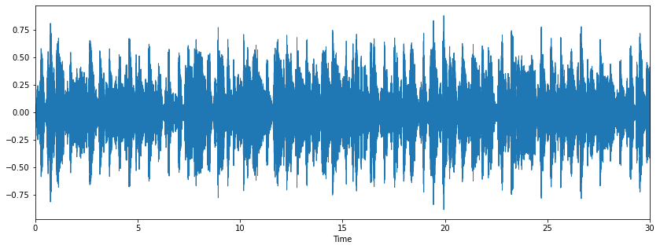
Figure: The above figure is the wave plot of the first song from the genre category – blues.
IV. MODELS
Before running the song through a training model, I spilt the Mel-Spectrogram data for each song in an 80-10-10 ratio, and it shall remain the same through the entirety of the project.
- Activation Functions
I’ve used two activation functions throughout the project. Two most suited activation functions for multi-class classification and Convolutional Neural Networks.
- Softmax Activation Function
It is an activation function which scales numbers into probabilities. The output of Softmax is a vector with the probabilities of each possible outcome. The probabilities in the vector sum to one for all possible outcomes. It is used for multi-classification in logistic regression.
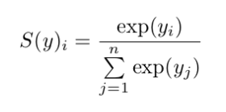
Where y is the input vector to a softmax function, y(i) is the i-th element of the input vector. Exp(y(i)) is the standard exponential function applied on y, n is the number of possible outcomes, and summation of exp(y(i)) is a normalization term.
- ReLu
ReLU (also known as Rectified Linear Activation Function) is a piecewise linear function that will output the input directly if it is positive, otherwise, it will output zero. It has become the default activation function for many types of neural networks, including Convolutional Neural Networks because the model that uses it is easier to train and often achieves better performance.
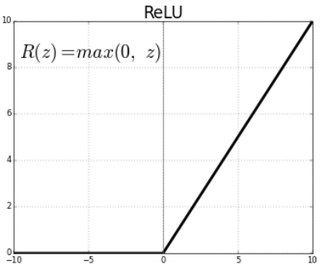
Figure: The above figure shows that ReLU is half rectified (from the bottom). f(z) is zero when z is less than zero and f(z) is equal to z when z is above or equal to zero.ReLU ranges from 0 to infinity.
The only problem with ReLU is that all values below 0 (negative) immediately become 0, which decreases the ability of the model to fit or train from the data properly.

- Optimizers
After building a Neural layer, the layer is compiled with an optimizer. An optimizer is an algorithm or method used to change the attributes of the neural network such as weights and learning rate in order to reduce the loss during the training of the neural network. I have used three optimizers in this project, and have compared them.
- Stochastic Gradient Descent
Stochastic Gradient Descent is a variant of Gradient Descent. It tries to update the model’s parameters more frequently. The model parameters are altered after computation of loss on each training example. If the dataset contains 100 rows, Stochastic Gradient Descent will update the model parameters 100 times in one cycle of the dataset instead of one time as in Gradient Descent. As the model parameters are frequently updated, the parameters have high variance and fluctuations in loss functions at different intensities
- Adam
Adaptive Moment Estimation or Adam works with momentums of first and second order. The intuition behind the Adam is that we don’t want to roll so fast just because we can jump over the minimum, we want to decrease the velocity a little bit for a careful search. In addition to storing an exponentially decaying average of past squared gradients like AdaDelta, Adam also keeps an exponentially decaying average of past gradients M(t).
- RMSProp
The RMSprop optimizer is similar to the gradient descent algorithm with momentum. The RMSprop optimizer restricts the oscillations in the vertical direction. Therefore, we can increase our learning rate and our algorithm could take larger steps in the horizontal direction converging faster. The difference between RMSprop and gradient descent is on how the gradients are calculated.

In addition to using such optimizers, I have also used a pre-trained model, namely VGG16 to compare the outcomes of a pre-trained model to a custom-built model
- VGG16
VGG16 is a convolutional neural network architecture named after Visual Geometry Group from Oxford, who developed it. The model loads a set of weights pre-trained on the ImageNet. ImageNet is a dataset over 15 million labelled high-resolution images belonging to roughly 22,000 categories. The architecture of VGG16 is as follows.
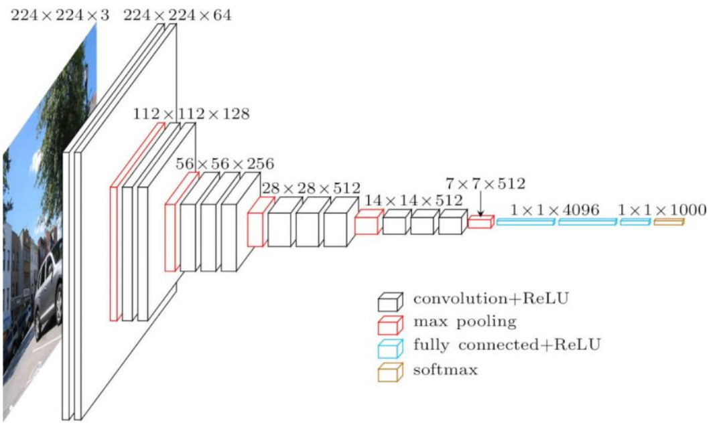

V. RESULTS
- Model 1
In the first model, I have a Convolutional Neural Network of four layers, each with the activation set as ReLU, with input_shape = (150, 150, 3). There is a MaxPooling layer after every convolutional layer with dropout set to 0.5. There is a final dense layer with softmax as the activation, and it is compiled using Adam optimizer. We ran it for 25 epochs.
 | Training | Validation | Test
Loss | 0.7284 | 1.4512 | 1.1621
Accuracy | 0.7400 | 0.5300 | 0.62

Our Model did pretty decent in the first run. But it was overfitting, and we could see a trend. Every model run after this would also overfit.
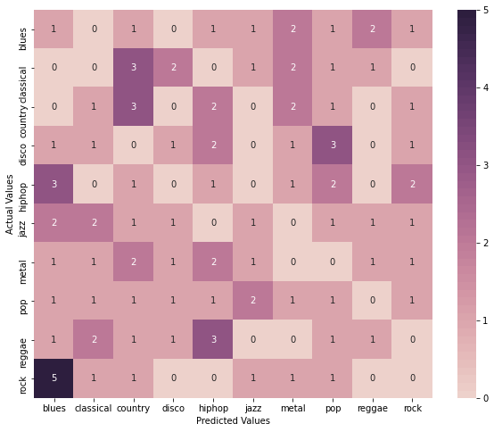
My model misclassified several genres as blues. It’s not surprising, since there are many sub-s=gneres of blues music that branch into other genres. Blues-rock is very popular as well as southern-rock which has country influences.
My model also had a tough time distinguishing between reggae and hip-hop. This makes sense since reggae music heavily influenced hip-hop music and share similar characteristics.
Such patterns will be common for the upcoming models as well.
- Model 2
In this model, I reduced the number of neurons in the last layer and changed the optimizer to Stochastic Gradient Descent to compare.

 | Training | Validation | Testing
Loss | 2.1187 | 2.1229 | 2.0801
Accuracy | 0.2200 | 0.2200 | 0.2099

Stochastic Gradient Descent performs the worst out of all my models. The maximum accuracy achieved on the validation set is 31%.
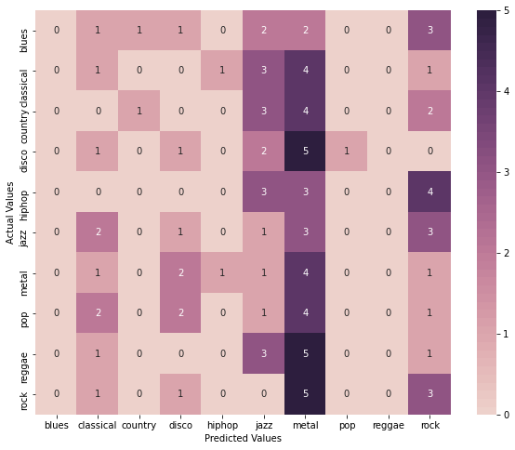
39 out of 100 songs were classified as Metal.

- Model 3
For Model 3, I reduced the layers, but subsequently, increased the number of neurons for each layer, and also reduced the dropout to 0.2. Change the optimizer back to Adam.
 | Training | Validation | Testing
Loss | 0.4935 | 2.4006 | 1.5494
Accuracy | 0.8125 | 0.4800 | 0.5400

As far as training accuracy is concerned, this model performed the best. But there was a huge difference between training accuracy and testing accuracy, thus implying that the model was highly overfitting the data.
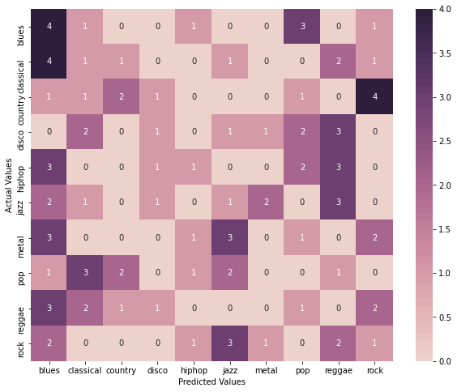
This model predicted blues the most number of times. 23 times it predicted a song to be of the genre blues.
- Model 4
In this model, I increased the number of neurons and changed the optimizer to RMSProp.
 | Training | Validation | Testing
Loss | 1.1313 | 1.6159 | 1.4418
Accuracy | 0.5975 | 0.5000 | 0.5400

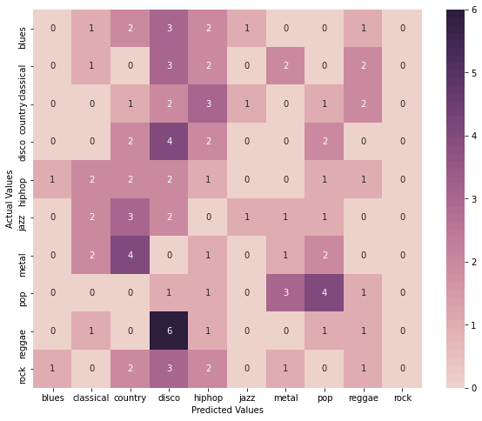
RMSProp did not overfit the model as much as other models were overfitting, but the outcome is still decent. It classified disco genre the most.
- Model 5 (VGG16)
I wanted to compare my custom-built model to a pre-trained model. I decided to you VGG16 because it had less number of layers and easy to train it for my Mel-Spectrograms.
 | Training | Validation | Testing
Loss | 0.3243 | 1.2711 | 0.9375
Accuracy | 0.9187 | 0.6100 | 0.699

This is the best testing accuracy I could achieve. This model was also severely overfitting.
Like RMSProp, VGG16 classified songs as disco the most.
VI. CONCLUSIONS
Most of the times, my model with optimizer set as adam performed better than the model which had optimizer set as RMSProp or SGD. Genre classification is very difficult for a human, and our model achieving 60% accuracy (70% accuracy in case of VGG16) is pretty commendable. I could still try to reduce the overfitting and try models with padding, but I wanted to compare models with similar architectures, just varying in either layers or optimizers.
VII. FUTURE WORK
There are several directions that would be interesting to pursue in the future. However, since music data is inherently sequential, other network structures such as LSTM (long short term memory) and GRU (gated recurrent unit) will likely achieve better performance. Moreover, if we are able to train a much deeper network that attains high accuracy, it would be interesting to plot the accuracy of a classical algorithm using different activation layers.

REFERENCES
- http://marsyas.info/downloads/datasets.html
- https://towardsdatascience.com/musical-genre-classification-with-convolutional-neural-networks-ff04f9601a74
- https://www.kdnuggets.com/2020/02/audio-data-analysis-deep-learning-python-part-1.html
- https://towardsdatascience.com/using-cnns-and-rnns-for-music-genre-recognition-2435fb2ed6af
- https://towardsdatascience.com/optimizers-for-training-neural-network-59450d71caf6
- https://medium.com/prathena/the-dummys-guide-to-mfcc-aceab2450fd

